IPL MATCH WINNER PREDICTION
USING MACHINE LEARNING

NAME : P.TAMIL CEELAN
COURSE : DATA ANALYTICS AND DATA SCIENCE
BATCH : AUGUST - 2025
DATE : 23/01/2026

IPL MATCH WINNER PREDICTION
1.INTRODUCTION
The Indian Premier League (IPL) is one of the most-watched cricket leagues in the world, from its beginning in 2008. Since then IPL has transformed cricket by blending high-intensity competition with entertainment and technology. Match outcomes are shaped by multiple factors such as team composition, toss decisions, venues and conditions of pitch.
Machine Learning is used for predicting match outcomes as manual prediction is difficult due to presence of dynamic environmental factors. Machine Learning uncovers patterns to make accurate predictions. This project uses ML to predict IPL match winners based on past seasons data enabling data-driven insights for fans, analysts, and sports strategists
2.PROJECT OBJECTIVE
- Developing ML models to predict match outcomes with high accuracy.
- Identifying and cleaning inconsistent data.
- Training multiple ML models for classification.
- Evaluating models using statistical metrics (Accuracy, Precision).
- Tuning model to optimize performance.

3. DATASET DESCRIPTION
The dataset used in the project consists of historical IPL match data collected over multiple years. Each row represents a single match.
3.1 KEY FEATURES
- Team1 & Team2 : Competing Teams
- Toss Winner : Team that won toss
- Toss Decision : Decision taken after winning the toss (Bating or Fielding )
- Venue : Stadium where the match was played
- Season : IPL season year
- Winner : Match winner
- Total matches: 756 Matches

4.DATA CLEANING
Data cleaning is a crucial phase in any machine learning project, as the performance and reliability of a model largely depend on the quality of the input data. Real-world datasets particularly sports datasets such as IPL match data—often suffer from issues like missing values, inconsistent naming conventions, and duplicate records. To address these challenges, a structured data cleaning process was implemented to ensure the dataset was accurate, consistent, and well-suited for model training.
4.1 HANDLING MISSING VALUES
Missing city values were filled. Records with missing winner values were given NAN.
4.2 STANDARDIZING TEAM NAMES
Team names were standardised by merging "Delhi Daredevils" into "Delhi Capitals" and "Rising Pune Supergiants" into “Rising Pune Supergaint” as it is same teams , to ensure categorical consistency.
  - REMOVING IRRELEVANT COLUMNS
Irrelevant or sparsely populated columns, such as umpire3 (which contained approximately 84% missing values), were removed to improve data quality and reduce noise.
5. EXPLORATORY DATA ANALYSIS
Exploratory Data Analysis (EDA) was performed to understand the underlying structure and patterns within the dataset. This step involved analyzing distributions, identifying trends, detecting outliers, and examining relationships between key variables such as teams, venues, toss decisions, and match outcomes. EDA helped uncover meaningful insights, validate assumptions, and guide feature selection for subsequent modeling stages.
5.1 EDA GOALS
Understand patterns in historical match data, visualizing match trends, team performance across seasons, and the impact of the toss on final results..

5.2 EDA INSIGHTS
- Teams like CSK and MI consistently had higher wins.
- Toss winning gives marginal edge but does not guarantee victory.
- Some teams performed significantly better at their home ground.
5.3 EDA VISUALS
- Total Matches per season

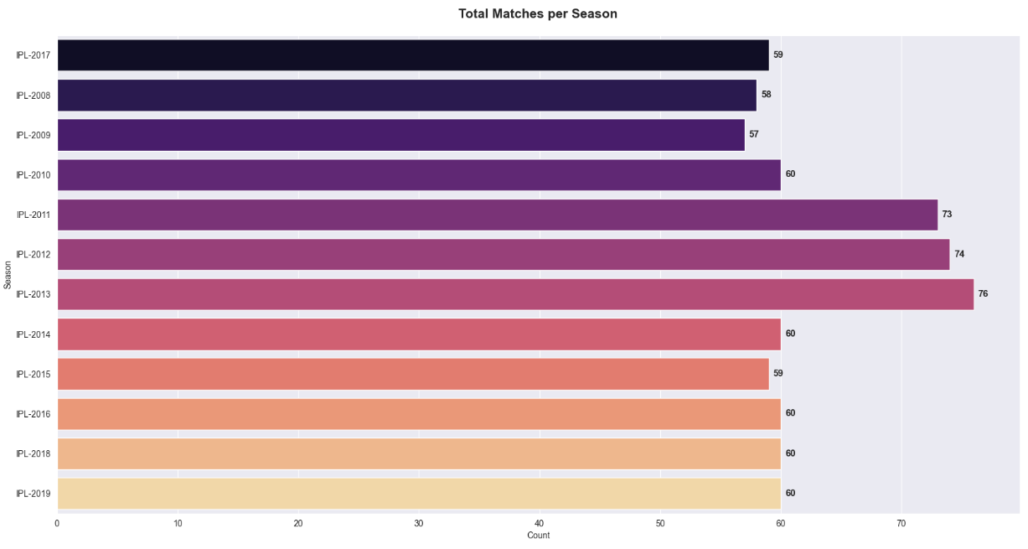
- Toss Decisions
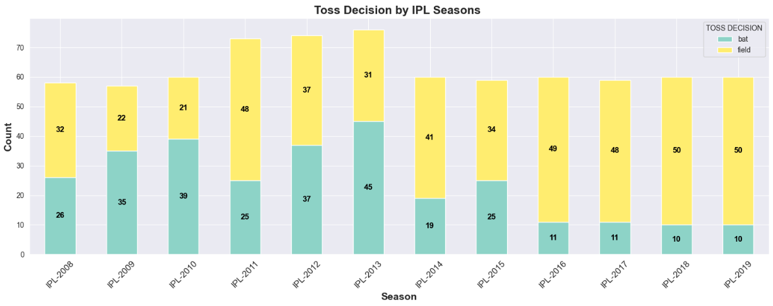
6.MODEL TRAINING
During the model training phase, the prepared dataset was used to train machine learning algorithms to predict match outcomes. The data was split into training data and testing sets to evaluate model performance objectively. Appropriate algorithms were selected based on the problem requirements, and model parameters were tuned to optimize performance. This phase ensured the model learned meaningful patterns from historical data while minimizing overfitting.
6.1 SUPERVISED LEARNING
Supervised learning is a machine learning approach in which models are trained using labelled data, where both input features and corresponding target outputs are known. The algorithm learns the relationship between these inputs and outputs to make accurate predictions on unseen data. In this project, supervised learning techniques were applied to predict match outcomes based on historical IPL data and relevant match-related features.
- FRAMEWORK
- Labeled Data
- Feature Set (X)
- Target Label (y)
6.2 MODELS IMPLEMENTED
The Project utilizes various supervised learning algorithms to find the most accurate relationship between match conditions and the outcome:
- Logistic Regression
Used as a baseline classifier to estimate the probability of a team winning based on a linear combination of features.
- Support Vector Machine (SVM)
A powerful supervised model that finds the optimal hyperplane to separate the win/loss classes. It is implemented it with an rbf kernel to capture non-linear relationships.
- K-Nearest Neighbors (KNN)
Predicts the winner based on the results of the "most similar" matches in the training set.
- Decision Trees & Random Forest
These models use a tree-like structure to make decisions based on feature thresholds.
- XGBoost

An advanced ensemble method that builds multiple trees sequentially to correct errors from previous ones, often providing the highest accuracy in sports prediction
6.3 IMPLEMENTATION
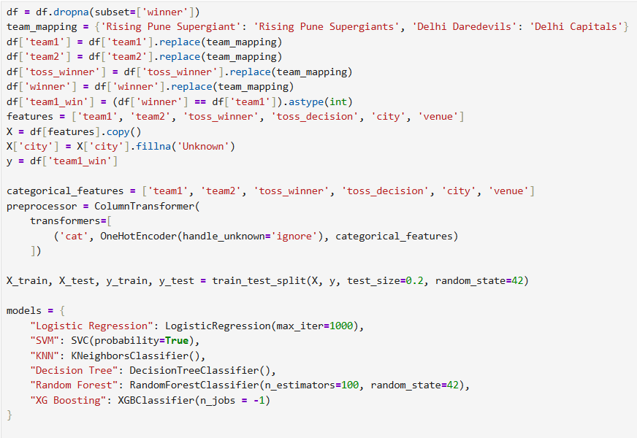
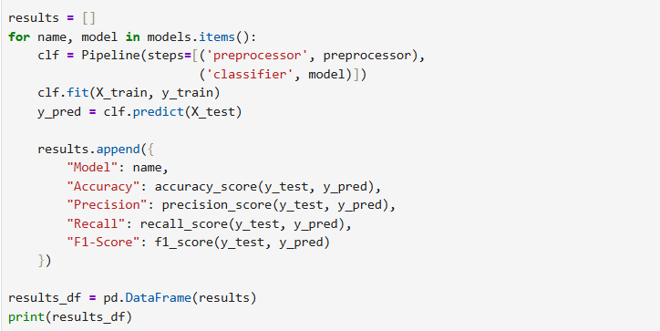
6.4 MODEL EVALUATION
The models were evaluated using the following metrics
Accuracy : Overall correctness of Predictions.
Precision : Correct positive predictions.
Recall : Ability to capture actual positives outcomes.
F1-Score : Mean of precision and recall.
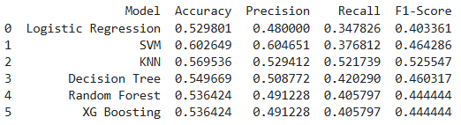
- SVM is considered for hyper tuning as it has highest Accuracy.
7.HYPERPARAMETER TUNING
7.1 TUNING SUPPORT VECTOR MACHINE (SVM)
Parameters taken for tuning
- C Parameter :
The C parameter controls the trade-off between maximizing
the margin and minimizing classification errors
- Kernels
The kernel function transforms input data into a higher-dimensional space, enabling the SVM to handle non-linear relationships.
- Gamma
Gamma defines how far the influence of a single training data point reaches.

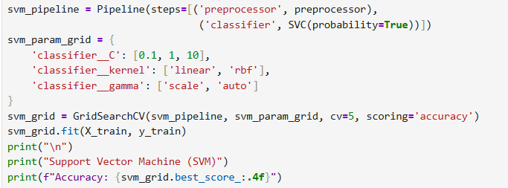
7.2 RESULT
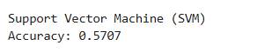
8.INSIGHTS
- Cities like Mumbai and Kolkata show high match frequencies.
- Teams who win toss most likely wins the matches.
- CSK and MI has the highest wins.
- Teams Choosing fielding first tend to score targets easily.
9.CONCLUSION
This project successfully demonstrates the effective application of machine learning techniques for predicting IPL match outcomes. Comprehensive data cleaning, in-depth exploratory data analysis, and careful feature engineering ensured the creation of a high-quality and reliable dataset. After evaluating multiple machine learning models, the Support Vector Machine (SVM) achieved the highest accuracy following hyperparameter tuning, highlighting its suitability and effectiveness for the prediction.

